Name : Sundara Moorthy
Reg No : 192324228
Course code : Cloud Computing And Big Data Analysis
Exp No : EXPERIMENT 15
Date : 23/12/2025
15. Creation and Testing of Snapshot in VMware Workstation
Aim
To create a snapshot of a Virtual Machine and restore it to a previous state using VMware Workstation.
Steps
- Power ON the Virtual Machine.
- Click VM → Snapshot → Take Snapshot.
- Enter snapshot name and description.
- Click Take Snapshot.
- Perform changes in the VM (install software or modify files).
- Open Snapshot Manager.
- Select the snapshot and click Go To.
Output
• Snapshot successfully created.
• Virtual Machine reverted to the saved snapshot state.
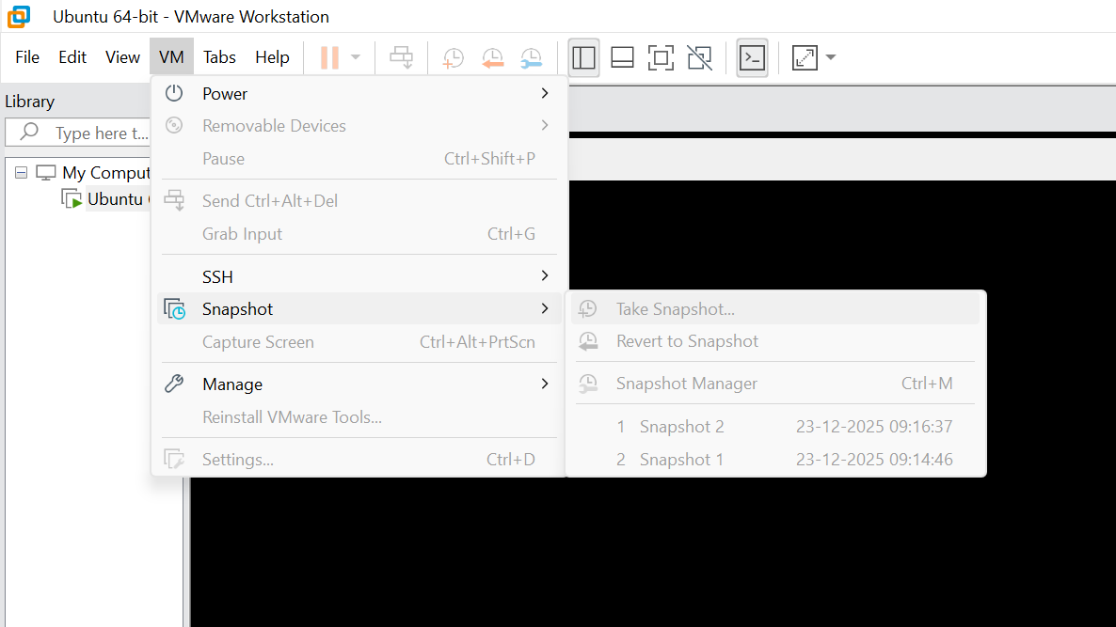

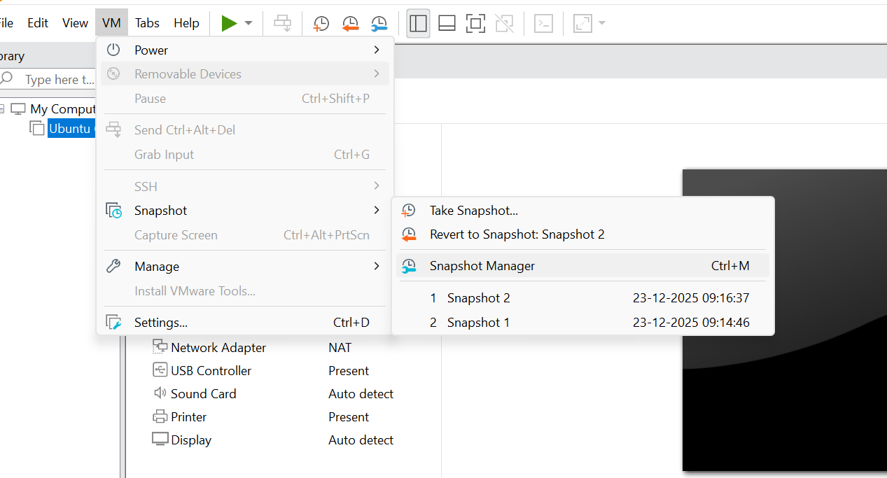
Result
Thus, snapshot creation and restoration were successfully performed using VMware Workstation.

